International Association of Athletics Federations | 

Monaco, 16 May 2011

LAT

Ref: WORLD RECORD

Dear Friends,

We are pleased to inform you that, in accordance with the IAAF Rule 260.12 & 13, the IAAF President, Mr Lamine DIACK and I, as IAAF General Secretary, have ratified as IAAF Javelin Throw Junior World Record, the performance achieved in Sofia, Bulgaria, on 20 March 2011, by Zigismunds SIRMAIS: 84.47m

Would you, please, be so kind to forward to your athlete the IAAF warmest congratulations.

The commemorative plaque will be handed over to you as soon as possible.

We leave you to decide what would be the best occasion to hand it over in a proper manner to the athlete and would appreciate to receive photos of this ceremony.

Best regards

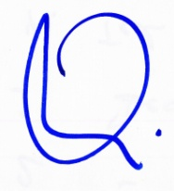

Pierre Weiss
IAAF General Secretary

Copy : EAA – PH – OC – ND – CT - TC

