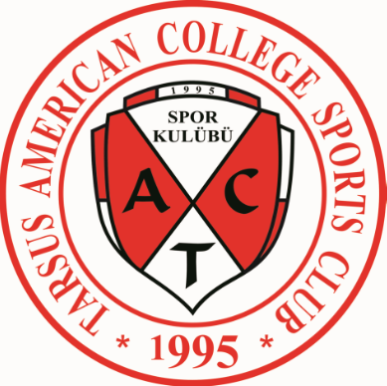
TARSUS AMERICAN COLLEGE SPORTS CLUB

Phone: 0 324 613 54 02 / 150 – 151
Fax: 0 324 624 63 47
Address: Caminur Mah Cengiz Topel Cad No: 64 PK: 33440 TARSUS / MERSİN

Invitation to the Güner Baykal Basketball Tournament

RE: International Tournament “11th Güner Baykal Basketball Tournament” - Tarsus, May 16 – 19, 2012

The Organizing Committee is pleased to invite you to the 11th International Güner Baykal Basketball Tournament. The tournament will be held in the city of Tarsus, which is in the Çukurova region of Turkey.

In the tournament, to which 8 teams will be attending, male athletes born in 1997 and 1998 will be competing. Each team will consist of 10 players minimum and 12 players maximum and they will perform in 5 matches. 1 team coach and 1 administrator will be accepted in the group in addition to the players.

Since the Tournament will start on May 16, 2012, teams coming from abroad need to check in their
hotels on May 15, 2012. Extra full board accomodation, as well as the costs of the social activities,
will be covered by the organization committee.

TRANSPORTATION:
The transportation from the airport and transfers between the hotel and the sports hall during
tournament will be provided for free by the organization committee.

The tournament will end with a closing ceremony on Saturday, May 19, 2012 at 13:30.

ACCOMODATION:
Full board accomodation will be provided by the organizing committee. Teams will be accomodated in 3 or 4-star hotels.

PARTICIPATION FEE:
The participation fee for the tournament is 200 Euros. The bank which this fee should be deposited is Garanti Bankası and the IBAN number is TR020006200015300009092797. Swift number is TGBATRIS153.

The fee will not be refunded in the the event that the team is unable to participate in the tournament.

DOCUMENTS REQUIRED FROM THE PARTICIPATING TEAMS:
- Team photo, national flag, national anthem, club logo
- Cloth size of the players, administrator and the team coach in the group
(XS-S-M-L-XL-XXL)

You can send the documents required electronically to alicekic@ttmail.com

The groups will bring their national flag with them. The deadline for e-mailing all other information is 15.02.2012.

Tarsus, September 20, 2012
TAC SPORTS CLUB ORGANIZING COMMITTEE

